Exercise 1
Creating the required tables and inserting data values to run the PL/SQL commands-
CREATE TABLE Customers (
CustomerID NUMBER PRIMARY KEY,
Name VARCHAR2(50),
Age NUMBER,
Balance NUMBER,
IsVIP NUMBER(1)
);

CREATE TABLE Loans (
LoanID NUMBER PRIMARY KEY,
CustomerID NUMBER,
DueDate DATE,
InterestRate NUMBER
);

CREATE TABLE SavingsAccounts (
AccountID NUMBER PRIMARY KEY,
Balance NUMBER
);

CREATE TABLE Employees (
EmployeeID NUMBER PRIMARY KEY,
DepartmentID NUMBER,
Salary NUMBER
);

CREATE TABLE Accounts (
AccountID NUMBER PRIMARY KEY,
Balance NUMBER
);
INSERT INTO Customers VALUES (1,'John',65,15000,0);
INSERT INTO Customers VALUES (2,'Mary',40,5000,0);

INSERT INTO Loans VALUES (101,1,SYSDATE+10,8);
INSERT INTO Loans VALUES (102,2,SYSDATE+50,7);

INSERT INTO SavingsAccounts VALUES (201,10000);

INSERT INTO Employees VALUES (301,10,50000);

INSERT INTO Accounts VALUES (401,20000);
INSERT INTO Accounts VALUES (402,5000);

COMMIT;
Scenario 1: The bank wants to apply a discount to loan interest rates for customers above 60 years old.
  - Question: Write a PL/SQL block that loops through all customers, checks their age, and if they are above 60, apply a 1% discount to their current loan interest rates.
PL/SQL command-
SET SERVEROUTPUT ON;
DECLARE

CURSOR customer_cursor IS
SELECT CustomerID, Age
FROM Customers;

BEGIN

FOR customer_record IN customer_cursor
LOOP

IF customer_record.Age > 60 THEN

UPDATE Loans
SET InterestRate = InterestRate - 1
WHERE CustomerID = customer_record.CustomerID;

END IF;

END LOOP;

COMMIT;

DBMS_OUTPUT.PUT_LINE('Loan discount applied');

END;
/
SELECT * FROM Loans;
OUTPUT
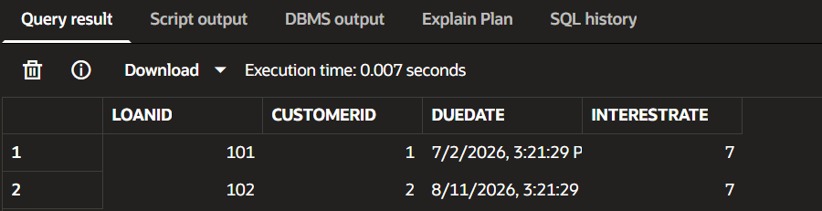
Scenario 2: A customer can be promoted to VIP status based on their balance.
  - Question: Write a PL/SQL block that iterates through all customers and sets a flag IsVIP to TRUE for those with a balance over $10,000.
PL/SQL Command:
DECLARE

CURSOR customer_cursor IS
SELECT CustomerID, Balance
FROM Customers;

BEGIN

FOR customer_record IN customer_cursor
LOOP

IF customer_record.Balance > 10000 THEN

UPDATE Customers
SET IsVIP = 1
WHERE CustomerID = customer_record.CustomerID;

END IF;

END LOOP;

COMMIT;

DBMS_OUTPUT.PUT_LINE('VIP status updated');

END;
/
SELECT * FROM Customers;
OUTPUT
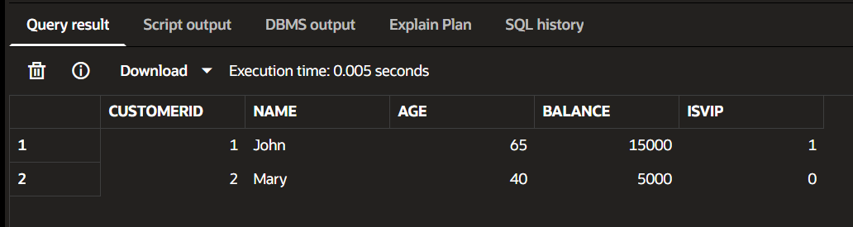
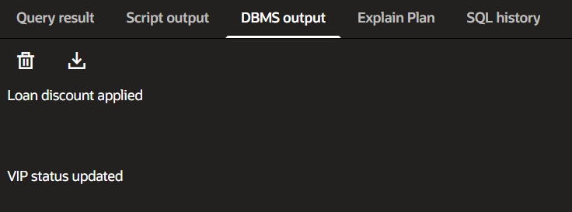
Scenario 3: The bank wants to send reminders to customers whose loans are due within the next 30 days.
  - Question: Write a PL/SQL block that fetches all loans due in the next 30 days and prints a reminder message for each customer.
PL/SQL Command:
DECLARE

CURSOR loan_cursor IS

SELECT CustomerID, LoanID, DueDate
FROM Loans
WHERE DueDate BETWEEN SYSDATE AND SYSDATE+30;

BEGIN

FOR loan_record IN loan_cursor

LOOP

DBMS_OUTPUT.PUT_LINE(
'Reminder: Customer ' ||
loan_record.CustomerID ||
' Loan ' ||
loan_record.LoanID ||
' due on ' ||
loan_record.DueDate
);

END LOOP;

END;
/
OUTPUT
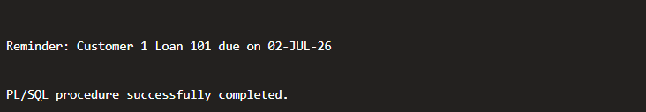
Exercise 3: Stored Procedures

Scenario 1: The bank needs to process monthly interest for all savings accounts.
  - Question: Write a stored procedure ProcessMonthlyInterest that calculates and updates the balance of all savings accounts by applying an interest rate of 1% to the current balance.
PL/SQL Command:
CREATE OR REPLACE PROCEDURE ProcessMonthlyInterest

IS

BEGIN

UPDATE SavingsAccounts

SET Balance = Balance + (Balance * 0.01);

COMMIT;

DBMS_OUTPUT.PUT_LINE(
'Monthly interest processed'
);

END;
/
EXEC ProcessMonthlyInterest;
SELECT * FROM SavingsAccounts;
OUTPUT
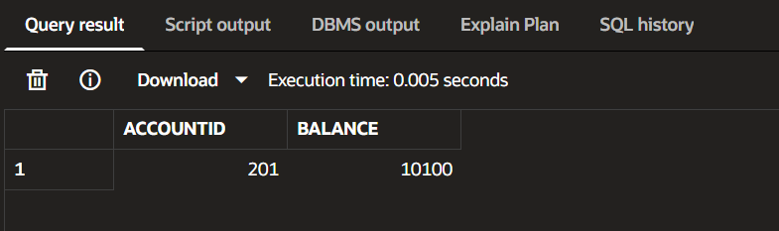
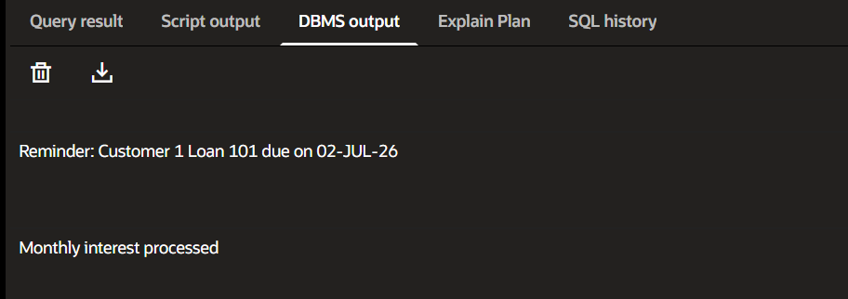
Scenario 2: The bank wants to implement a bonus scheme for employees based on their performance.
  - Question: Write a stored procedure UpdateEmployeeBonus that updates the salary of employees in a given department by adding a bonus percentage passed as a parameter.
PL/SQL Command:
CREATE OR REPLACE PROCEDURE UpdateEmployeeBonus

(
p_department_id NUMBER,
p_bonus_percentage NUMBER
)

IS

BEGIN

UPDATE Employees

SET Salary = Salary +
(Salary * p_bonus_percentage / 100)

WHERE DepartmentID = p_department_id;

COMMIT;

DBMS_OUTPUT.PUT_LINE(
'Bonus updated'
);

END;
/
EXEC UpdateEmployeeBonus(10,5);
SELECT * FROM Employees;
OUTPUT
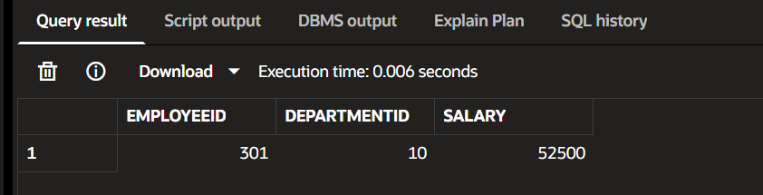
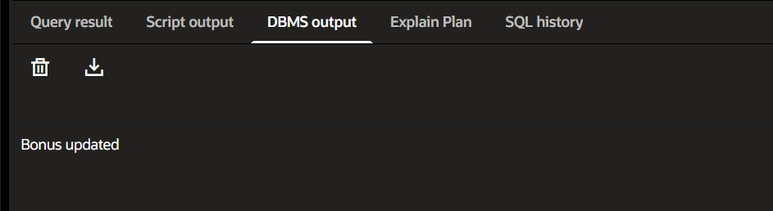
Scenario 3: Customers should be able to transfer funds between their accounts.
  - Question: Write a stored procedure TransferFunds that transfers a specified amount from one account to another, checking that the source account has sufficient balance before making the transfer.

PL/SQL Command:
CREATE OR REPLACE PROCEDURE TransferFunds

(
p_source_account NUMBER,
p_target_account NUMBER,
p_amount NUMBER
)

IS

v_balance NUMBER;

BEGIN

SELECT Balance
INTO v_balance

FROM Accounts

WHERE AccountID = p_source_account;

IF v_balance >= p_amount THEN

UPDATE Accounts

SET Balance = Balance - p_amount

WHERE AccountID = p_source_account;

UPDATE Accounts

SET Balance = Balance + p_amount

WHERE AccountID = p_target_account;

COMMIT;

DBMS_OUTPUT.PUT_LINE(
'Transfer successful'
);

ELSE

DBMS_OUTPUT.PUT_LINE(
'Insufficient balance'
);

END IF;

EXCEPTION

WHEN NO_DATA_FOUND THEN

DBMS_OUTPUT.PUT_LINE(
'Account not found'
);

END;
/
EXEC TransferFunds(401,402,5000);
SELECT * FROM Accounts;
OUTPUT
